**First we will create table employee using create command**

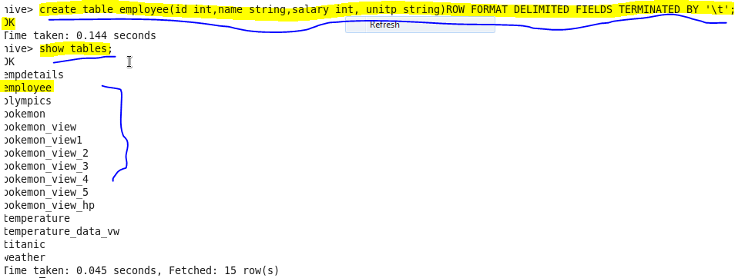

**now we will load our dataset employee.txt using LOAD command**

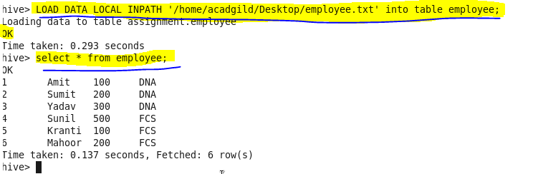

**Get a list of employees who receive a salary less than 100, compared to their immediate employee with higher salary in the same unit**

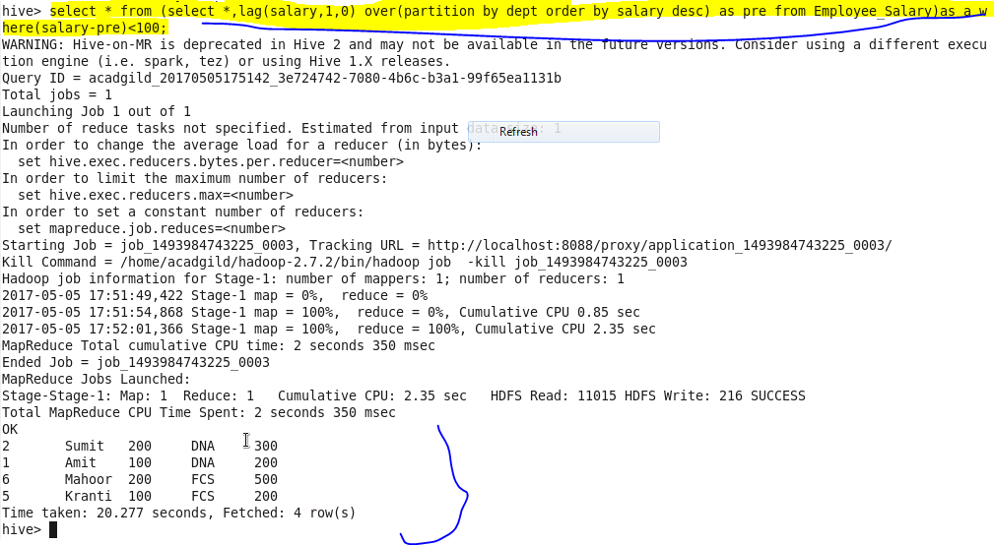

**List of all employees who draw higher salary than the average salary of that department.**

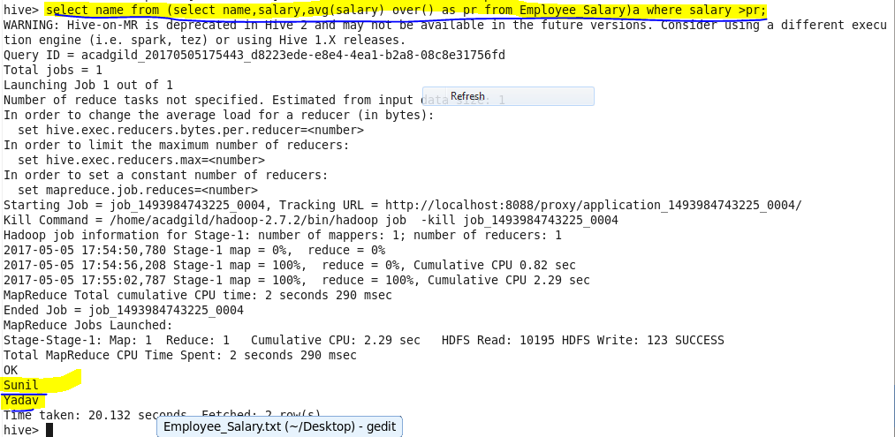

**SEQUENCEFILE**

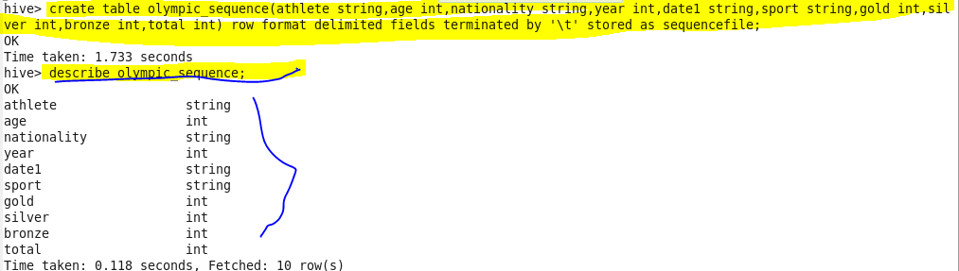

**Insert data :**

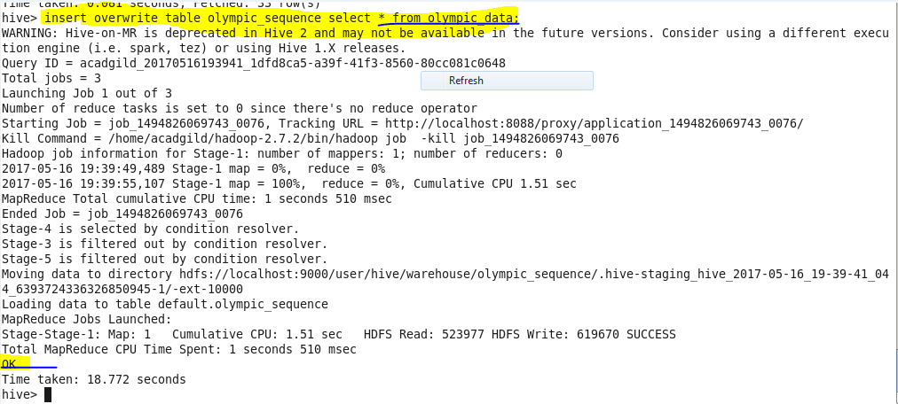

Showing result :

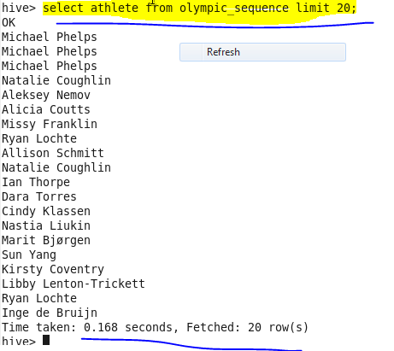

**RCFILE**

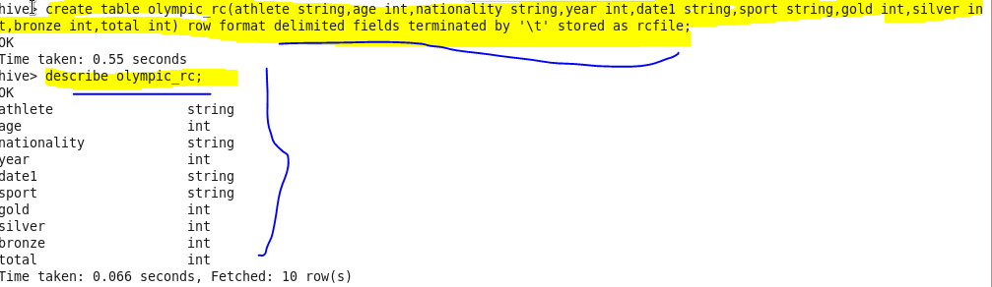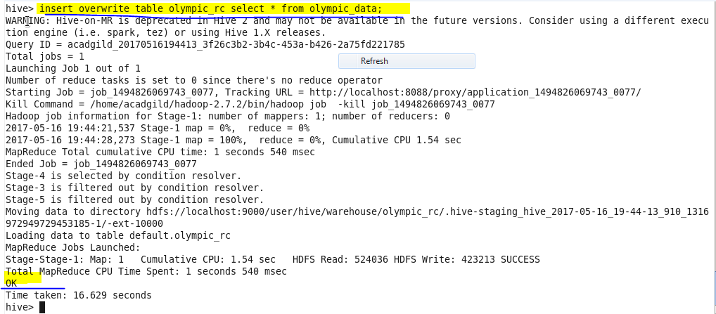

**Showing result**

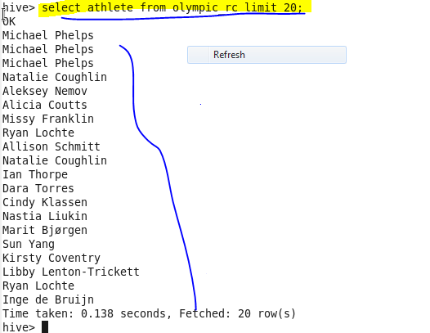

**ORC FILE**

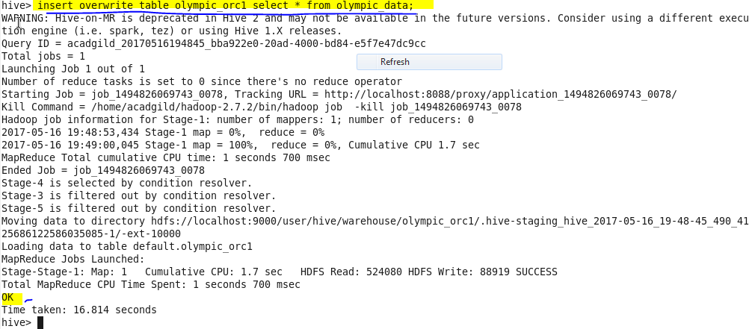

**Showing result:**

